A Project Report on
Blood Donation Finder

Submitted by:
Sulav Tiwari
, Symbol No: 24080305
P.U. Registration Number: 2024-2-08-0044
Aryan Mainalee
Symbol No: 24080269
P.U. Registration Number: 2024-02-08-0008
Deepesh Bastola
Symbol No: 24080275
P.U. Registration Number: 2024-2-08-0014

Submitted to
Ace Institute of Management
Pokhara University

In partial fulfillment of the requirement for the degree of
Bachelors of Computer System and Information Technology

Kathmandu
June, 2026
SUPERVISOR RECOMMENDATION
This is to certify that this project entitled, “Blood Donation Finder” prepared and submitted by Aryan Mainalee, Sulav Tiwari and Deepesh Bastola in partial fulfillment of the requirements of the degree of Bachelor of Computer System and Information Technology (BCSIT) awarded by Pokhara University, has been completed under my supervision. I recommend the same for acceptance by the University.

……………….
Supervisor
Ayush Dhital
Ace Institute of Management

CERTIFICATE OF APPROVAL
This project entitled, “Blood Donation Finder” prepared and submitted by Aryan Mainalee, Sulav Tiwari and Deepesh Bastola, has been examined and is accepted for the award of the degree of Bachelor of Computer System and Information Technology (BCSIT) awarded by Pokhara University.

…..…..…………….. …………………..
Supervisor Examiner
Ayush Dhital
Ace Institute of Management

…………………… …………………..
Associate Director Director
Ramesh Chauhan Aashish Tiwari
Ace Institute of Management Ace Institute of Management

ABSTRACT
The Blood Donation Finder is a real-time web-based platform designed to connect blood donors and recipients quickly during medical emergencies. The project aims to address the lack of a centralized and efficient blood donor management system in Nepal, where patients and families often face significant delays in finding compatible blood donors.
The proposed system enables donors to register their blood type, location, and availability, while recipients can submit urgent blood requests through an easy-to-use interface. Using automated matching based on blood group and geographical location, the platform instantly notifies suitable donors. The system also incorporates real-time communication through in-app chat, email notifications, secure authentication, and donor history management.
The platform is developed using modern web technologies including HTML, CSS, JavaScript, Node.js, Express.js, MySQL, and Socket.io. A feasibility study confirms that the project is technically, operationally, and economically viable. By replacing manual donor search methods with a structured digital solution, the Blood Donation Finder is expected to reduce emergency response times, improve donor participation, and strengthen blood donation services in Nepal.

ACKNOWLEDGEMENT
We would like to express our sincere gratitude to our project supervisor, Mr. Sanju Shrestha, for his valuable guidance, encouragement, and continuous support throughout the development of this project.
We would also like to thank our institution, faculty members, and classmates for providing the necessary resources, knowledge, and constructive feedback that contributed to the successful completion of this project.
Special appreciation goes to all the authors, researchers, and organizations whose published works and resources helped us understand the challenges of blood donation systems and healthcare technology.
Finally, we thank our families and friends for their motivation, patience, and support during the preparation of this project proposal.

Contents
CHAPTER 2: LITERATURE 1
2.1 Description of fundamental theories, general concepts and 1
terminologies related to the project 1
2.1.1 Blood Donation System 1
2.1.2 Blood Donation and Blood Groups 1
2.1.3 Health Information Systems 1
2.1.4 Real-Time Communication Systems 1
2.1.5 Database Management Systems (DBMS) 2
2.1.6 Web-Based Applications 2
2.1.7 Notification Systems 2
2.1.8 Donor Matching Concept 2
2.2 Review of the similar Projects and Theories 2
2.2.1 BloodConnect 2
2.2.2 HamroLifeBank 3
2.2.3 Blood Supply Chain Theory 3
2.2.4 Emergency Response Theory 3
2.2.5 Comparative Analysis of Existing Systems 4
2.2.6 Summary of Literature Review 4
CHAPTER 3: SYSTEM AND ANALYSIS DESIGN 5
3.1 System Analysis 5
3.2 Requirement Analysis 5
3.2.1 Functional Requirements 5
3.2.2 Non-Functional Requirements 8
3.3 Feasibility Analysis 9
3.3.1 Technical 9
3.3.2 Operational 9
3.3.3 Financial 9
3.3.4 Schedule 10
3.4 Data Modeling 10
3.5 Process Modelling 10
3.6 System Design 13
3.6.1 Architectural Design 13
3.6.2 Database Schema Design 15
3.6.3 Interface Design (UI Interface / Interface Structure Diagrams) 17
3.6.4 Physical Model 17
CHAPTER 4: IMPLEMENTATION & TESTING 18
4.1 Implementation 18
4.1.1 Tools Used (CASE tools, Programming languages, Database platforms) 18
4.1.2 Implementation Details of Modules (Description of procedures/functions) 18
4.2 Testing 19
4.2.1 Test Cases for Unit Testing 19
4.2.2 Test Cases for System Testing 20
CHAPTER 5: CONCLUSION AND FUTURE RECOMMENDATIONS 21
5.1 Lesson Learnt 21
5.2 Conclusion 21
5.3 Recommendations 22
APPENDICES 23
REFERENCES 30

List of Tables
Table 1: Comparative Analysis of Existing Systems 4
Table 2: Test Cases for Unit Testing 19
Table 3: Test Cases for System Testing 20

List of Figures:
Figure 1: Use Case Diagram (Admin) 6
Figure 2: Use Case Diagram (Donor) 7
Figure 3: Use Case Diagram (Organization) 8
Figure 4: Flowchart 12
Figure 5: Architecture Diagram 14
Figure 6: ER Diagram 16

List of Abbreviations
API: Application Programming Interface
CSS: Cascading Style Sheets
DBMS: Database Management System
ER: Entity Relationship
HIS: Health Information System
HTML: HyperText Markup Language
JWT: JSON Web Token
SMS: Short Message Service
ST: System Testing
SQL: Structured Query Language
TC: Test Case
UI: User Interface

CHAPTER 2: LITERATURE

2.1 Description of fundamental theories, general concepts and

terminologies related to the project

2.1.1 Blood Donation System
A blood donation system is a framework that facilitates the collection, management, and distribution of blood from donors to recipients. The primary objective of such systems is to ensure the availability of safe and compatible blood during medical emergencies, surgeries, and treatments. Efficient blood management is essential because blood cannot be artificially manufactured and depends entirely on voluntary donations (Paudel, 2024).

2.1.2 Blood Donation and Blood Groups
Blood donation is the voluntary act of giving blood to help individuals requiring transfusions. Human blood is classified into different blood groups, including A, B, AB, and O, along with positive and negative Rh factors. Compatibility between donor and recipient blood types is crucial for successful transfusion procedures.
Studies have shown that increasing public participation in voluntary blood donation can significantly improve healthcare services and emergency response capabilities (Raihan, 2023).

2.1.3 Health Information Systems
A Health Information System (HIS) refers to a digital platform used to collect, process, store, and manage healthcare-related information. Blood donation management systems are a specialized category of health information systems that facilitate donor registration, blood request management, and communication between stakeholders.

2.1.4 Real-Time Communication Systems
Real-time communication systems enable instant information exchange between users. In blood donation platforms, real-time communication allows donors to receive emergency notifications immediately after a blood request is submitted. Technologies such as Socket.io support bidirectional communication between users and servers, improving response times during emergencies.

2.1.5 Database Management Systems (DBMS)
A Database Management System is software used to store, organize, and retrieve data efficiently. In this project, MySQL is used to maintain donor records, recipient information, blood requests, donation history, and communication logs. Database systems ensure data consistency, integrity, and security.

2.1.6 Web-Based Applications
A web application is software that operates through a web browser using internet technologies. Web-based systems provide accessibility from multiple devices and locations. The proposed Blood Donation Finder utilizes HTML, CSS, JavaScript, Node.js, and Express.js to create an accessible and user-friendly platform.

2.1.7 Notification Systems
Notification systems automatically inform users about important events. In blood donation management, notifications play a critical role in alerting donors about urgent blood requirements. Email and real-time notifications can significantly reduce donor response time and improve emergency coordination.

2.1.8 Donor Matching Concept
Donor matching refers to the process of identifying suitable donors based on blood group compatibility, geographical location, and donor availability. Automated matching algorithms improve efficiency by reducing manual searching and ensuring faster responses during emergencies.

2.2 Review of the similar Projects and Theories

2.2.1 BloodConnect
BloodConnect is a digital platform designed to connect blood donors with recipients. The platform allows users to search for blood donors and request blood during emergencies. It promotes voluntary blood donation and provides a structured method of connecting donors with individuals in need.
The platform demonstrates how technology can improve accessibility to blood donors and reduce delays associated with traditional donor search methods. However, some features may depend on user participation and donor availability at the time of the request (BloodConnect, n.d.).

2.2.2 HamroLifeBank
HamroLifeBank is one of Nepal's most recognized blood donation applications. It enables users to register as donors, search for donors, and support blood donation campaigns. The application has contributed significantly to improving awareness and participation in voluntary blood donation across Nepal.
HamroLifeBank demonstrates the effectiveness of digital solutions in addressing blood shortages. However, there remains an opportunity to enhance emergency response through improved real-time communication and donor matching mechanisms (HamroLifeBank, n.d.).

2.2.3 Blood Supply Chain Theory
According to research on blood supply chain management, efficient coordination among donors, blood banks, hospitals, and recipients is essential for maintaining adequate blood availability. Delays in communication and poor information management often result in shortages and inefficient resource utilization (Imamoglu, 2023).
The proposed Blood Donation Finder supports this theory by establishing a centralized platform that improves communication and coordination among stakeholders.

2.2.4 Emergency Response Theory
Emergency response theory emphasizes the importance of rapid communication and timely resource allocation during critical situations. Blood availability is a crucial factor in emergency healthcare services. Quick identification and notification of compatible donors can significantly improve patient outcomes (Vasconcelos, 2023).
The proposed system applies this theory by using real-time notifications and automated donor matching to reduce delays during emergencies.

2.2.5 Comparative Analysis of Existing Systems
Table 1: Comparative Analysis of Existing Systems
Feature | BloodConnect | HamroLifeBank | Proposed Blood Donation Finder
Donor Registration | Yes | Yes | Yes
Blood Request Posting | Yes | Yes | Yes
Real-Time Notifications | Limited | Limited | Yes
In-App Chat | No | No | Yes
Donor Matching by Location | Yes | Yes | Yes
Donation History | Limited | Limited | Yes
Admin Dashboard | Limited | Limited | Yes
Real-Time Communication | Limited | Limited | Yes

2.2.6 Summary of Literature Review
The reviewed literature and existing platforms indicate that digital blood donation systems improve donor accessibility, communication efficiency, and emergency response. Studies highlight the importance of donor management, blood supply chain optimization, and real-time communication in healthcare services. Existing platforms such as BloodConnect and HamroLifeBank provide valuable foundations; however, the proposed Blood Donation Finder aims to further enhance emergency donor matching, communication, and system efficiency through modern web technologies.

CHAPTER 3: SYSTEM AND ANALYSIS DESIGN

3.1 System Analysis
The Blood Donation Finder system is designed to address the inefficiencies in the traditional blood donation process in Nepal, where patients often struggle to find compatible donors during emergencies. The current system relies heavily on manual communication methods such as phone calls, social media, and personal networks, which are slow and unreliable.
The proposed system introduces a centralized, web-based platform that connects donors and recipients in real time. It analyzes user needs, system limitations, and operational challenges in existing processes. The system ensures faster communication, improved donor availability tracking, and automated matching based on blood type and location.
The system analysis focuses on identifying how users interact with the platform, including donor registration, blood request submission, donor matching, notifications, and communication between stakeholders.

3.2 Requirement Analysis
The requirement analysis defines the functional and non-functional needs of the system to ensure it meets user expectations effectively.

3.2.1 Functional Requirements
- User registration and login system for donors, recipients, and organizations
- Donor profile management including blood type, location, and availability
- Blood request creation by recipients
- Automated donor matching based on blood group and location
- Real-time notifications for emergency blood requests
- In-app communication system between donors and recipients
- Admin dashboard for monitoring users and requests
- Donation history tracking for donors

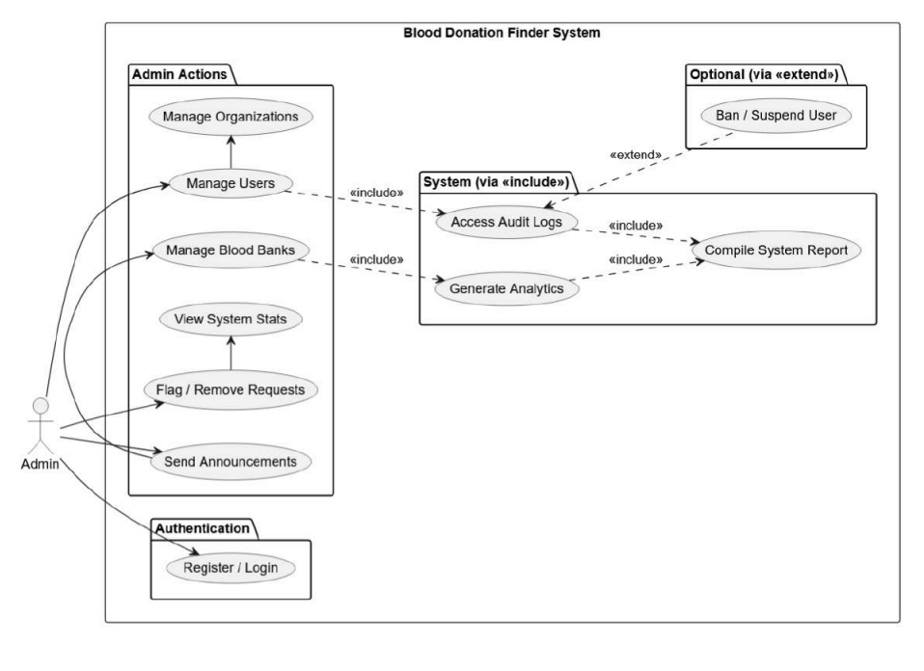
Figure 1: Use Case Diagram (Admin)

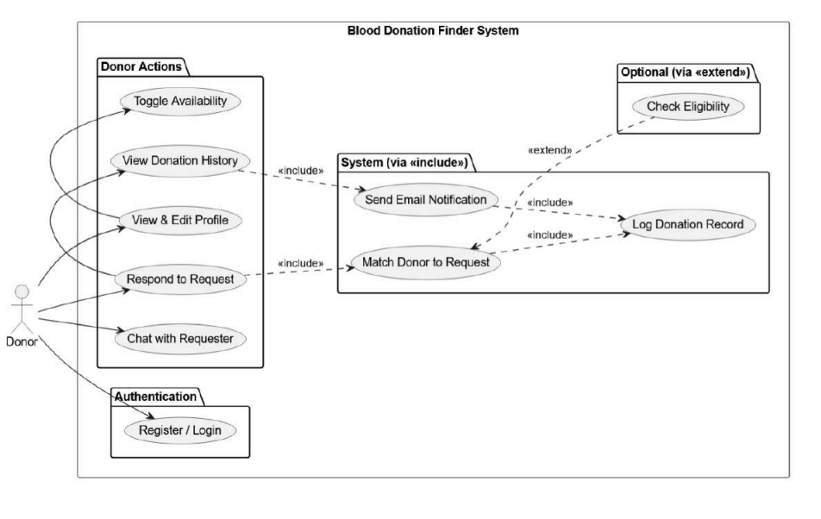
Figure 2: Use Case Diagram (Donor)

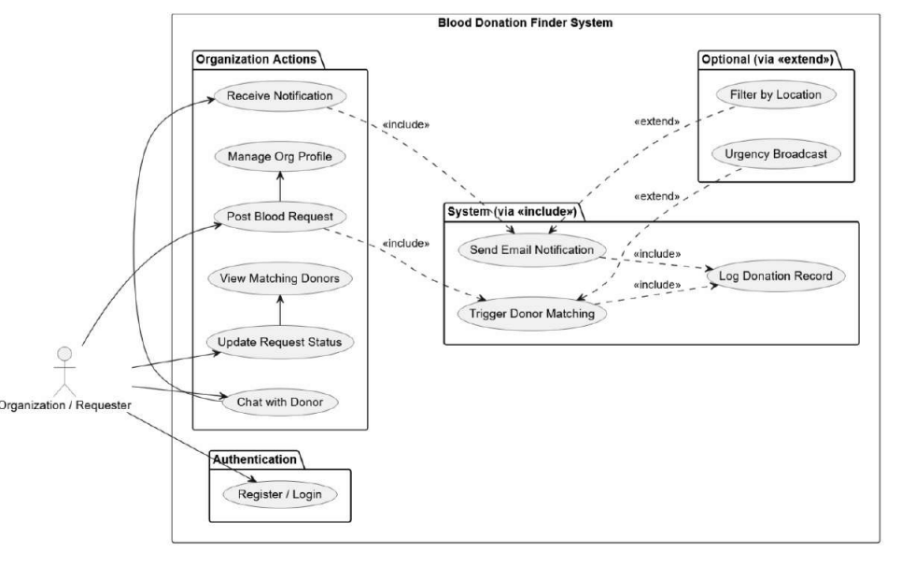
Figure 3: Use Case Diagram (Organization)

3.2.2 Non-Functional Requirements
Non-functional requirements define system performance, reliability, and quality standards.
- Performance: The system should respond quickly with minimal delay during donor matching and notifications.
- Scalability: The platform should support increasing numbers of users without performance degradation.
- Security: User data, including personal and medical information, must be securely stored using authentication and encryption techniques.
- Usability: The system should have a simple and user-friendly interface suitable for all types of users.
- Reliability: The system should ensure high availability, especially during emergency situations.
- Maintainability: The system should be easy to update and maintain with modular architecture.

3.3 Feasibility Analysis
Feasibility analysis evaluates whether the proposed system is practical and achievable within technical, operational, financial, and time constraints.

3.3.1 Technical
The project is technically feasible using modern and widely adopted web technologies. The system uses HTML, CSS, and JavaScript for the frontend, Node.js and Express.js for backend development, MySQL for database management, and Socket.io for real-time communication.
These technologies are open-source, well-documented, and widely supported by developer communities. Real-time features such as notifications and chat are achievable using Socket.io, while secure authentication is implemented using JWT. Therefore, the system can be successfully developed with available technical resources.

3.3.2 Operational
The system is operationally feasible as it is designed with a simple and intuitive user interface. Users such as donors, recipients, and organizations can easily operate the system without requiring technical training.
The workflow for blood request submission, donor matching, and notifications is automated, reducing manual effort. The system can be maintained by a small administrative team after deployment, making it practical for real-world usage.

3.3.3 Financial
The project is financially feasible because it is developed using open-source technologies that do not require licensing costs. The main expenses include hosting, domain registration, and minimal server maintenance.
Since this is an academic project, development costs are minimal. Compared to the social benefit of saving lives through faster blood donation access, the cost of implementation is very low and justified.

3.3.4 Schedule
The project is feasible within the planned academic timeline of approximately 10 to 13 weeks. The development process is divided into structured phases including planning, design, implementation, testing, and documentation.
Each phase is assigned specific tasks such as requirement gathering, UI design, database creation, backend development, feature integration, and final testing. This structured approach ensures timely completion of the project within the academic schedule while maintaining quality output.

3.4 Data Modeling
Data modeling defines how data is structured, stored, and managed in the Blood Donation Finder system. It represents the relationship between different entities such as donors, recipients, blood requests, and administrators.
The system follows a structured relational model where:
- A User can act as a donor.
- A Donor has attributes such as blood group, location, and availability status
- A Blood Request is created by a recipient and linked to potential donors
- An Admin manages system activities and user records
The data model ensures consistency, reduces redundancy, and supports efficient retrieval of information during emergency situations.

3.5 Process Modelling
Process modeling describes the workflow and interaction between different components of the system.
The main processes in the Blood Donation Finder include:
- User Registration Process: Users register by providing personal details and blood group information.
- Login Process: Users authenticate using secure credentials.
- Blood Request Process: A recipient submits a blood request specifying blood type, location, and urgency.
- Donor Matching Process: The system automatically filters and identifies compatible donors based on blood group and geographical location.
- Notification Process: Matching donors receive real-time notifications through the system.
- Communication Process: Donors and recipients communicate through an integrated chat system after acceptance.
- Request Completion Process: Once blood is provided, the request status is updated to completed.
These processes ensure smooth operation and real-time response during emergencies.

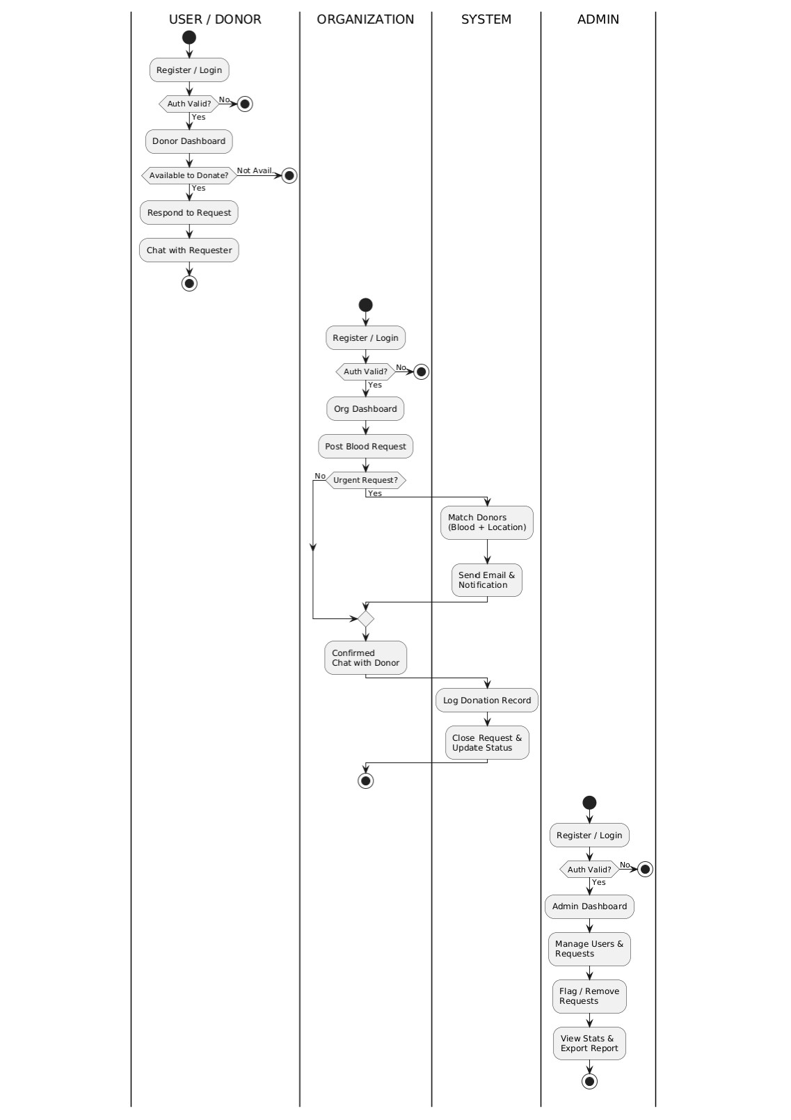
Figure 4: Flowchart

3.6 System Design
The system design of the Blood Donation Finder focuses on building a scalable, secure, and user-friendly platform that supports real-time blood donor matching and communication.

3.6.1 Architectural Design
The Blood Donation Finder system is developed based on a structured client-server architecture consisting of four distinct layers, each responsible for a specific aspect of the system's functionality. This layered approach ensures a clear separation of concerns, improves scalability, and supports efficient system performance.
The first layer is the Frontend Layer, which serves as the presentation tier of the system. It is built using HTML, CSS, and JavaScript and is responsible for providing an interactive and user-friendly interface accessible through a web browser. This layer includes all key interface components such as the Home Page, User Dashboard, Blood Request Page, Donor List Page, Chat Interface, and Admin Panel. Users including donors, recipients, organizations, and administrators interact with the system entirely through this layer.
The second layer is the Backend Layer, which acts as the core processing engine of the system. Developed using Node.js and Express.js, this layer handles all business logic, processes incoming API requests from the frontend, and manages communication between the user interface and the database. It also handles secure user authentication and session management through the use of JSON Web Tokens (JWT), ensuring that only authorized users can access protected resources.
The third layer is the Real-Time Communication Layer, implemented using Socket.io. This layer is responsible for enabling instant, bidirectional communication between users. It supports the in-app chat functionality that allows donors and recipients to communicate directly, as well as the real-time notification system that instantly alerts compatible donors when a new blood request is posted on the platform.
The fourth and final layer is the Database Layer, which is built on MySQL, a relational database management system. This layer is responsible for the persistent storage and retrieval of all structured data within the system, including user profiles, donor records, blood requests, notifications, chat messages, and donation history. Primary and foreign keys are used across the tables to maintain relational integrity and ensure data consistency.
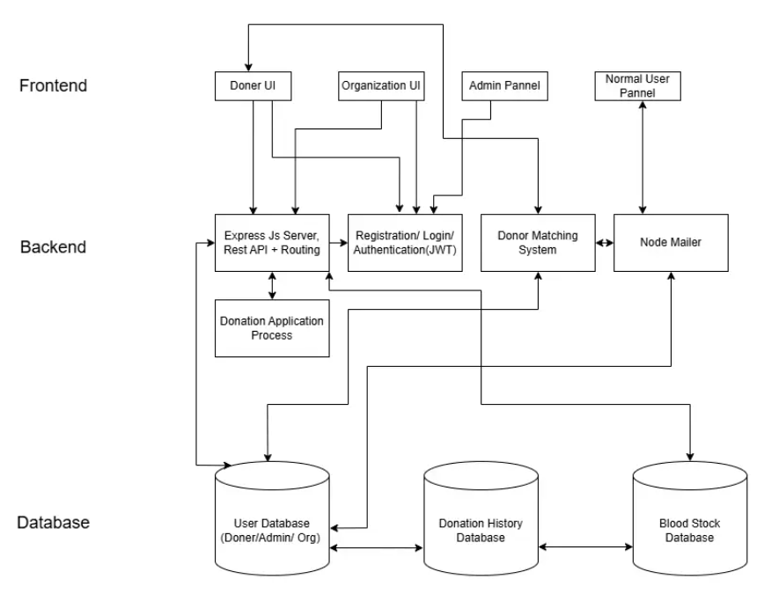
Together, these four layers form a cohesive and well-structured system in which user requests flow from the frontend to the backend, where they are processed and either stored in the MySQL database or dispatched as real-time events through Socket.io back to the relevant users.
Figure 5: Architecture Diagram

3.6.2 Database Schema Design
The database is designed using a relational structure to maintain data integrity and efficient access. Key tables include:
- Users Table: Stores user information such as name, email, password, role, and contact details.
- Donors Table: Stores blood group, location, and availability status.
- Blood Requests Table: Stores request details such as blood type, urgency level, location, and status.
- Notifications Table: Stores alerts sent to donor’s regarding blood requests.
- Chat Table: Stores messages exchanged between donors and recipients.
- Donation History Table: Records completed donations.
Primary and foreign keys are used to maintain relationships between tables and ensure data consistency.

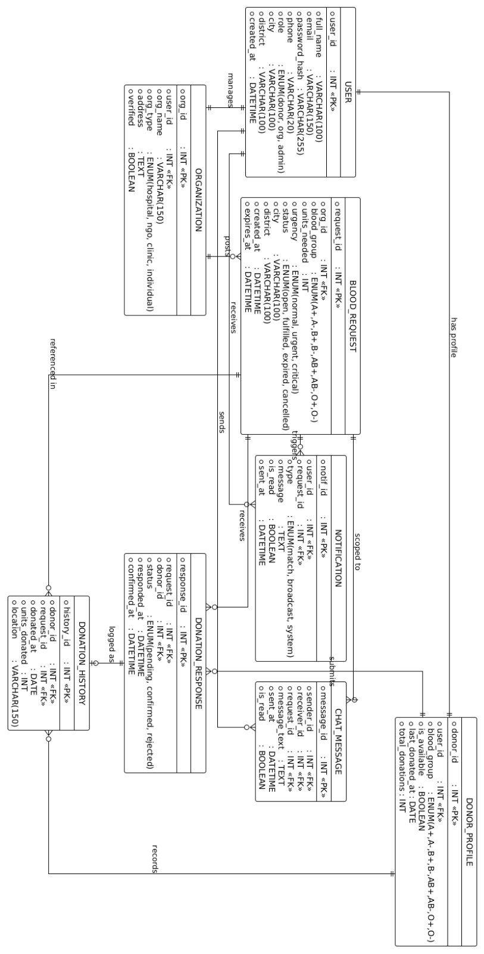
Figure 6: ER Diagram

3.6.3 Interface Design (UI Interface / Interface Structure Diagrams)
The user interface of the system is designed to be simple, responsive, and accessible for all users, including non-technical individuals.
Key interface components include:
- Home Page: Provides overview and access to login and registration
- User Dashboard: Displays donor/recipient information and active requests
- Blood Request Page: Allows users to create and view requests
- Donor List Page: Shows available donors based on matching criteria
- Chat Interface: Enables real-time communication between users
- Admin Panel: Allows system administrators to manage users and monitor activities
The design follows a minimal and clean layout to ensure ease of navigation and quick access during emergencies.

3.6.4 Physical Model
The physical model describes how the system is implemented in a real environment using hardware and software components.
The system is deployed on a cloud-based or local server that hosts the backend application and database. Users access the system through web browsers on devices such as mobile phones, tablets, or computers.
The physical setup includes:
- Web server for hosting Node.js application
- MySQL database server for data storage
- Client devices for user access
- Internet connectivity for real-time communication
This model ensures that the system can operate efficiently in real-world conditions with reliable access and performance.

CHAPTER 4: IMPLEMENTATION & TESTING

4.1 Implementation
The implementation phase focuses on developing a working version of the Blood Donation Finder system based on the proposed design. In this project, the implementation is currently limited to a responsive user interface, basic frontend functionality, and database connection during the login process.
The system allows users to interact with a simple web interface, register/login, and validate credentials through a connected MySQL database. The UI is designed to be responsive so that it can be accessed properly on different screen sizes such as mobile phones, tablets, and desktop devices.
At this stage, the system mainly demonstrates core functionality such as user authentication flow, UI navigation, and backend database connectivity.

4.1.1 Tools Used (CASE tools, Programming languages, Database platforms)
The following tools and technologies are used in the current implementation:
- Frontend Technologies: HTML, CSS, JavaScript (for UI design and responsiveness)
- Backend Technology: Node.js with Express.js (for handling login and server requests)
- Database Platform: MySQL (for storing user login credentials)
- Development Tool: Visual Studio Code
- Browser Tools: Google Chrome Developer Tools (for testing responsiveness and debugging)
These tools are sufficient for building the current prototype stage of the system.

4.1.2 Implementation Details of Modules (Description of procedures/functions)
1. User Interface Module
This module focuses on designing a clean and responsive interface for users. It includes login pages, registration pages, and basic navigation structure. The interface adapts to different screen sizes for better usability.
2. Authentication Module
This module handles user login functionality. When a user enters credentials, the system connects to the MySQL database to verify the information. If the credentials match, the user is granted access; otherwise, an error message is displayed.
3. Database Connection Module
This module establishes a connection between the backend server and MySQL database. It enables the system to store and retrieve user login data securely during authentication.

4.2 Testing
Testing is performed to verify that the implemented features work correctly. Since the current system is in the prototype stage, testing mainly focuses on UI responsiveness, login functionality, and database connectivity.

4.2.1 Test Cases for Unit Testing
Table 2: Test Cases for Unit Testing
Test Case ID | Module | Test Description | Expected Result | Status
TC01 | UI Design | Open website on desktop browser | Layout should display correctly | Pass
TC02 | UI Design | Open website on mobile device | Layout should adjust responsively | Pass
TC03 | Login System | Enter valid username and password | User should be logged in successfully | Pass
TC04 | Login System | Enter invalid credentials | Error message should appear | Pass
TC05 | Database Connection | Attempt login with stored user data | System should verify from MySQL | Pass

4.2.2 Test Cases for System Testing

Table 3: Test Cases for System Testing
Test Case ID | Scenario | Description | Expected Outcome | Status
ST01 | UI Responsiveness | Test layout on multiple screen sizes | UI remains responsive and usable | Pass
ST02 | Login Flow | Complete login process with valid credentials | User successfully logs in | Pass
ST03 | Login Failure Handling | Enter incorrect credentials | System denies access and shows error | Pass
ST04 | Database Connectivity | Check connection between backend and MySQL | Data retrieval works correctly | Pass
ST05 | Page Navigation | Navigate between login and home pages | Pages load without errors | Pass

CHAPTER 5: CONCLUSION AND FUTURE RECOMMENDATIONS

5.1 Lesson Learnt
During the development of the Blood Donation Finder system, several important technical and practical lessons were learned. The project helped in understanding how a web application is structured from the frontend to the backend and how it interacts with a database system.
The implementation phase provided experience in designing responsive user interfaces using HTML, CSS, and JavaScript. It also improved understanding of how backend systems using Node.js and Express.js handle user requests and connect with MySQL databases for data validation and storage.
Another key learning outcome was understanding the importance of database connectivity, especially during authentication processes such as login systems. The project also highlighted the importance of testing UI responsiveness across different devices to ensure usability.
Overall, the project improved problem-solving skills, technical knowledge, and understanding of how even a simple system prototype can form the foundation for a larger real-world application.

5.2 Conclusion
The Blood Donation Finder system was successfully developed as a basic working prototype that includes a responsive user interface and a functional login system connected to a MySQL database.
The system demonstrates how users can interact with a web-based platform to log in securely and access the system. Although the current version is limited to UI and authentication features, it effectively shows the foundation of a real-time blood donation platform.
The project successfully meets its initial objective of developing a functional prototype and provides a strong base for future development. It also shows how web technologies can be used to create simple but meaningful solutions for real-world problems such as emergency blood donation management.

5.3 Recommendations
Based on the current stage of development, the following recommendations are suggested for future improvement:
- The system should be extended by adding full donor and recipient modules.
- Blood request and donor matching features should be implemented to make the system fully functional.
- Real-time communication features such as chat and notifications should be added.
- Security improvements such as password encryption and session management should be strengthened.
- A full admin dashboard should be developed for system monitoring and control.
- The system should be deployed on a cloud platform for real-world testing and accessibility.
- A mobile application version can be developed for better user accessibility.
These improvements will help transform the current prototype into a complete and scalable real-world blood donation management system.

APPENDICES

Homepage:
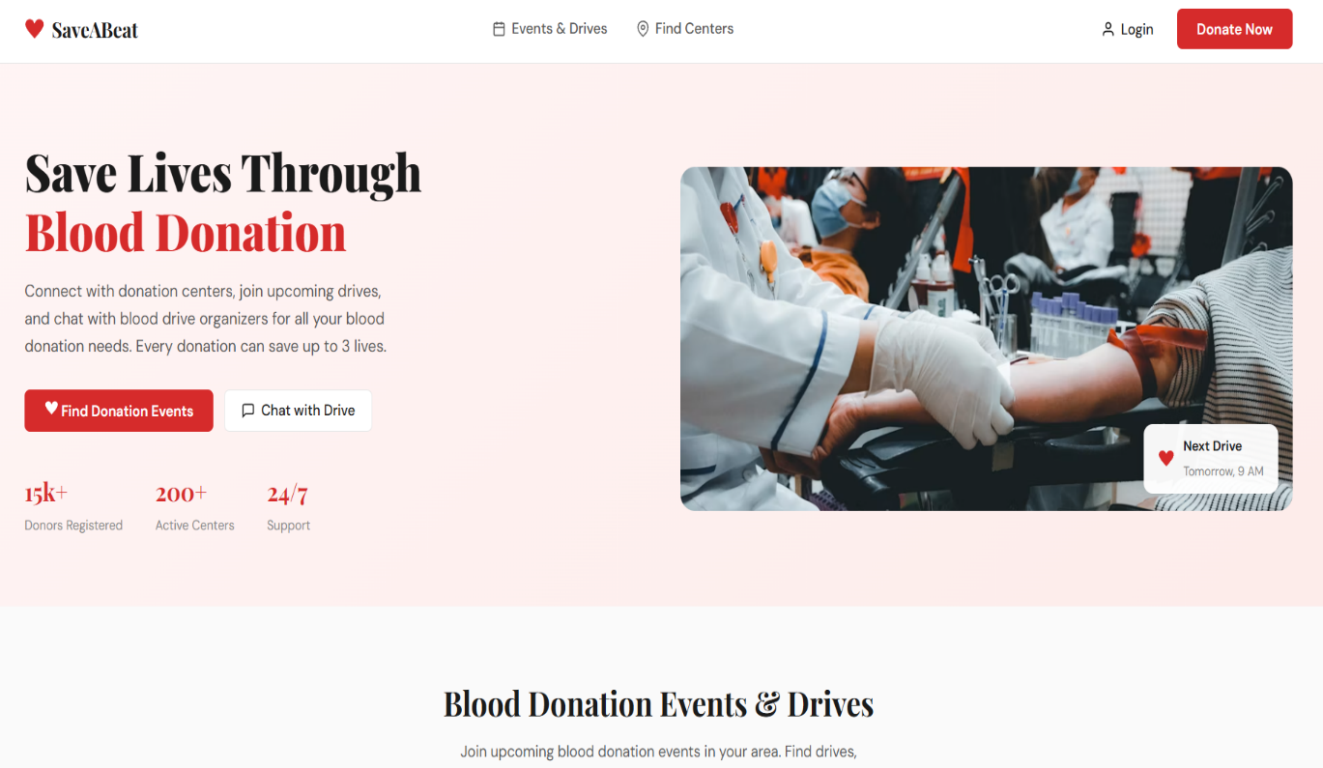

Login:

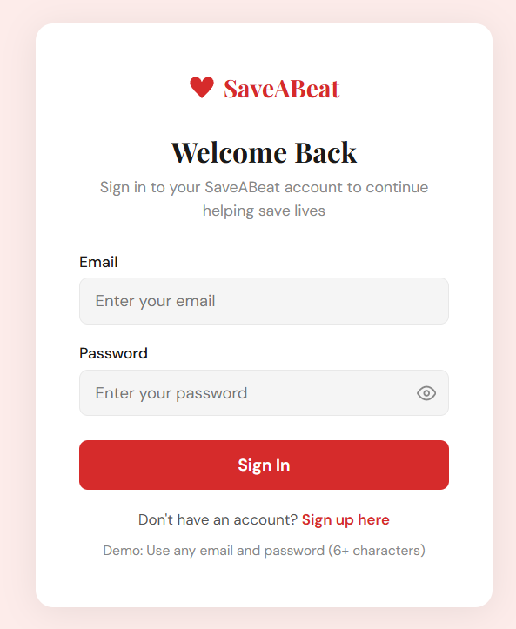
Signup:

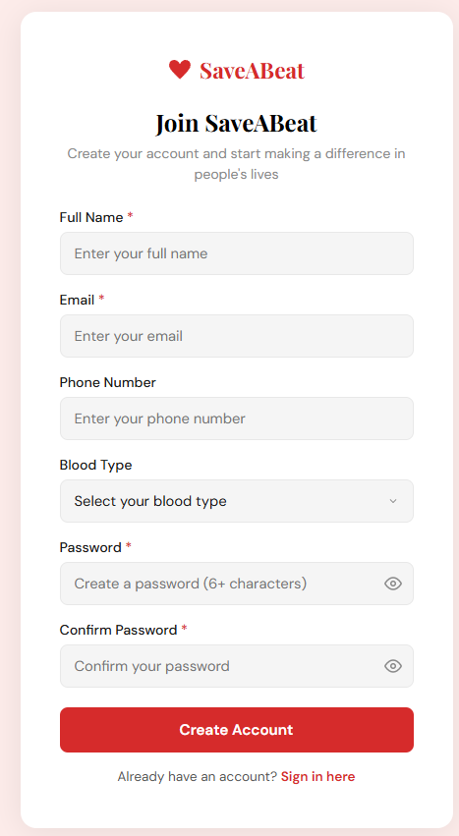
Browse Blood Drives:
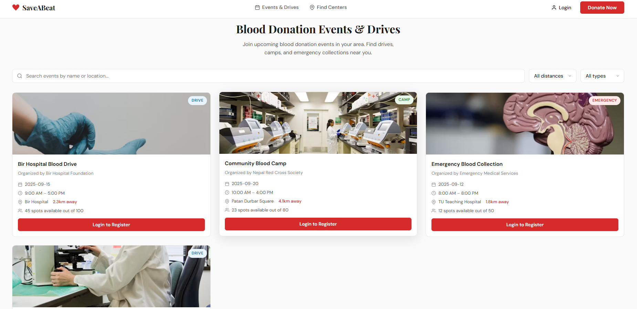

Organization:
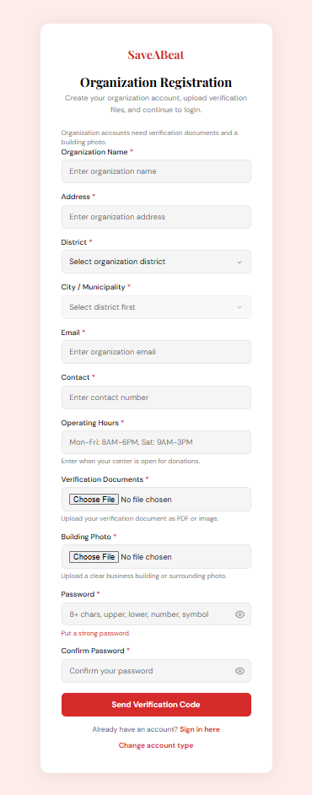

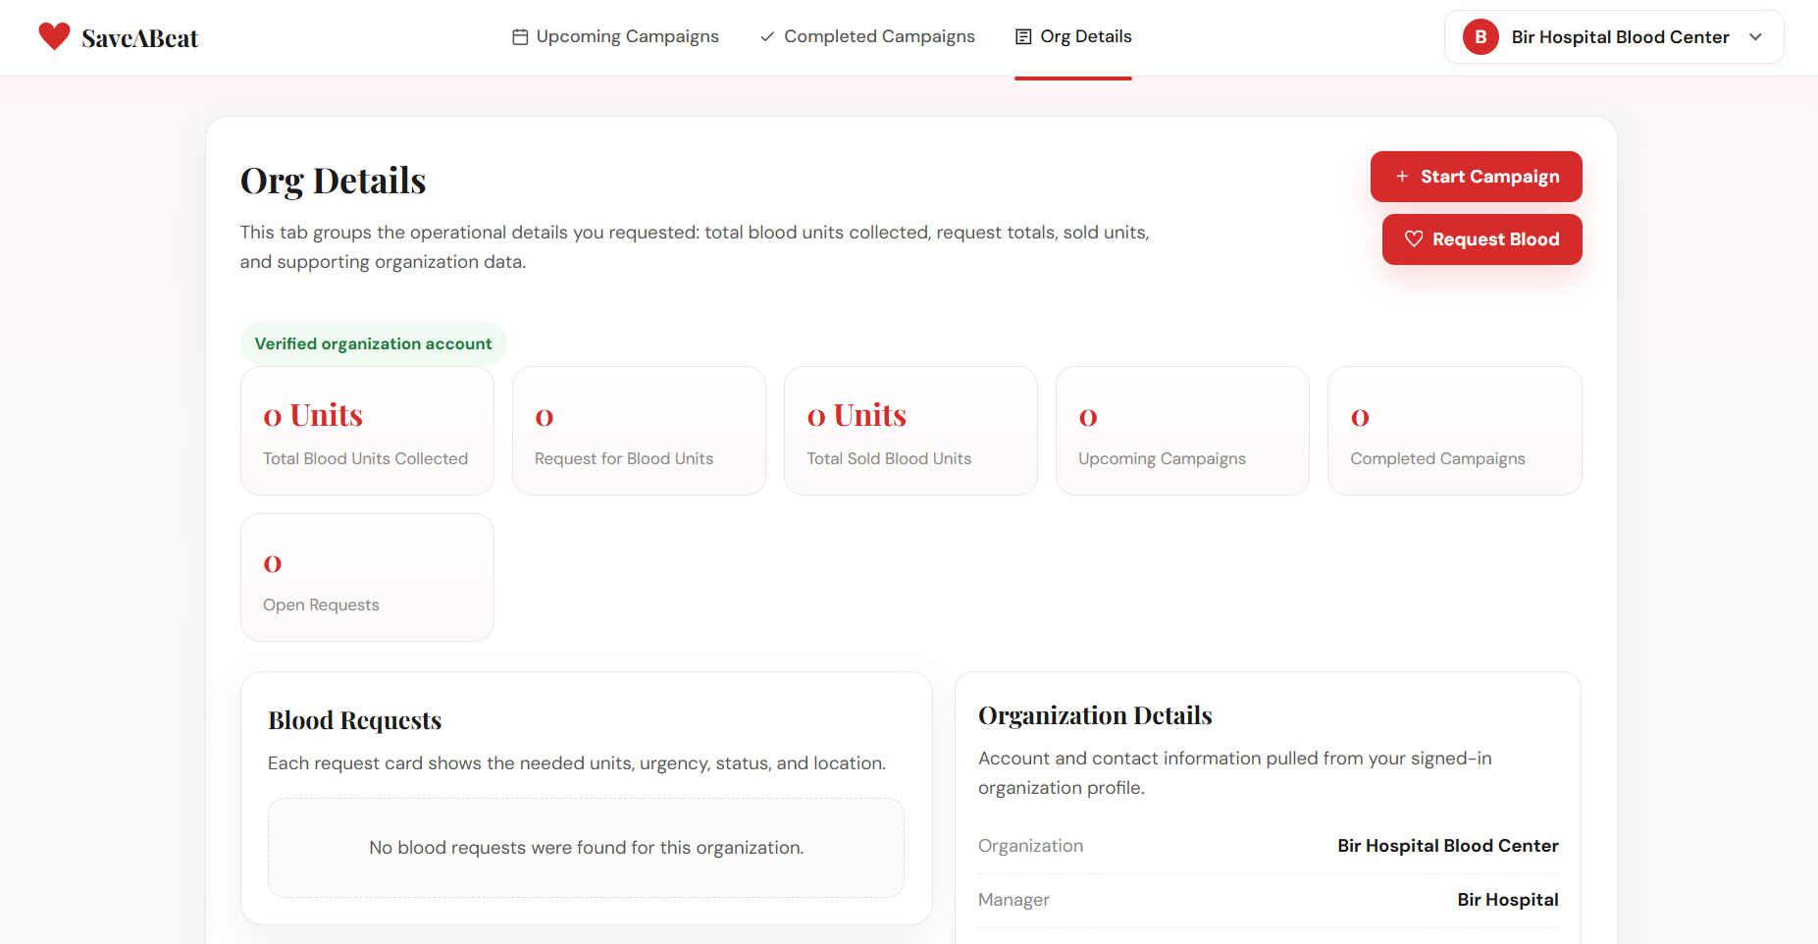
Admin:
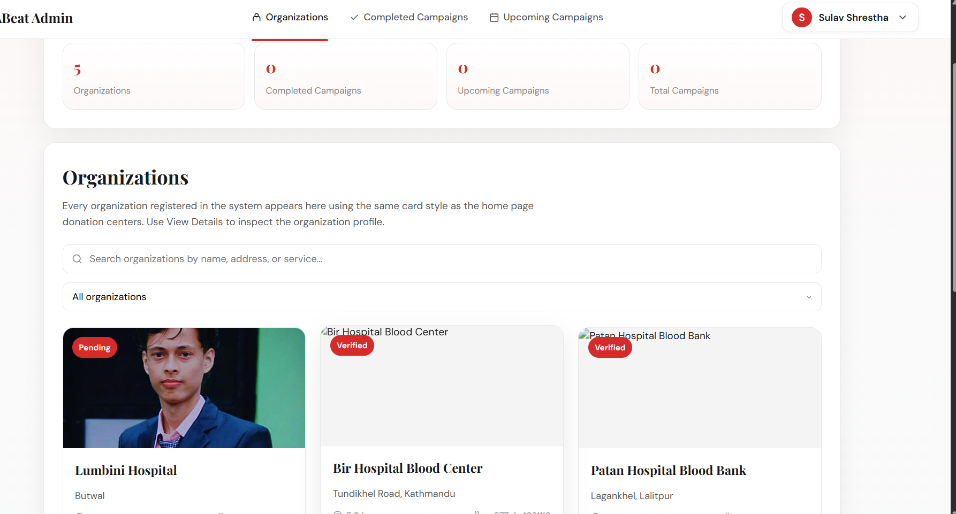

REFERENCES
BloodConnect. Blood donor connection platform. https://bloodconnect.org/
Imamoglu, G., Topcu, Y. I., & Aydin, N. (2023). A systematic literature review of the blood supply chain through bibliometric analysis and taxonomy. Systems, 11(3), 124. https://www.mdpi.com/2079-8954/11/3/124
Paudel, P., & Nepal, B. (2025). Blood transfusion services in Nepal: An overview. https://www.researchgate.net/publication/394055105_Blood_transfusion_services_in_Nepal_An_overview
Raihan, M. A., Shrestha, S., & Bhandari, R. (2023). Knowledge, attitude and practice of voluntary blood donation among higher education students in Nepal. PJRI. https://nepjol.info/index.php/pjri/article/download/87678/66464
Sankalp India Foundation / HamroLifeBank. Blood donation app for Nepal. https://hamrolifebank.com/
Vasconcelos, F. T., Faddy, H. M., Merollini, K. M. D., Flower, R. L. P., Dean, M. M., & Viennet, E. (2023). Impact of natural disasters and pandemics on blood supply: A systematic review. https://www.sciencedirect.com/science/article/pii/S2772632023000132

